**Page Factory in Selenium** is an inbuilt Page Object Model framework concept for Selenium WebDriver but it is very optimized. It is used for initialization of Page objects or to instantiate the Page object itself. It is also used to initialize Page class elements without using “FindElement/s.”

Here as well, we follow the concept of separation of Page Object Repository and Test Methods. Additionally, with the help of class PageFactory in Selenium, we use annotations **@FindBy** to find WebElement. We use initElements method to initialize web elements

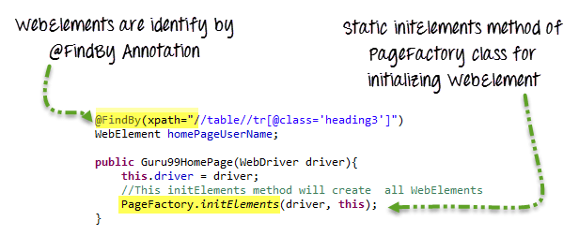

**@FindBy** can accept **tagName, partialLinkText, name, linkText, id, css, className, xpath**as attributes.

* **@FindBy**: An annotation used in Page Factory to locate and declare web elements using different locators. Below is an example of declaring an element using **@FindBy**

@FindBy(id="elementId") WebElement element;

Similarly, one can use **@FindBy** with different location strategies to find web elements and perform actions on them. Below are [locators](https://www.browserstack.com/guide/locators-in-selenium) that can be used:

* + ClassName
  + CSS
  + Name
  + Xpath
  + TagName
  + LinkText
  + PartialLinkText
* **initElements()**: **initElements** is a static method in Page Factory class. Using the **initElements** method, one can initialize all the web elements located by **@FindBy** annotation.
* **lazy initialization:** **AjaxElementLocatorFactory** is a lazy load concept in Page Factory. This is used to identify web elements only when they are used in any operation or activity. The timeout of a web element can be assigned to the object class with the help of the**AjaxElementLocatorFactory**.